# **27. OSPF: PART 2 (IGP: LINK STATE)**

## **OSPF Metric (Cost)**

* OSPF's metric is called **COST**.
* It is automatically calculated based on the bandwidth (speed) of the interface.
* It is calculated by dividing a **reference bandwidth** value by the **interface bandwidth**.
* The **default reference bandwidth** is 100 Mbps:
  + Reference: 100 Mbps / Interface: 10 Mbps = Cost (10)
  + Reference: 100 Mbps / Interface: 100 Mbps = Cost (1)
  + Reference: 100 Mbps / Interface: 1000 Mbps = Cost (1)
  + Reference: 100 Mbps / Interface: 10000 Mbps = Cost (1)
* All cost values less than 1 will be converted to 1.
* Therefore, FastEthernet (100 Mbps), Gigabit Ethernet (1000 Mbps), 10 Gig Ethernet, etc., are equal and all have a cost of 1.

### **FastEthernet Cost**

### **Gigabit Ethernet Cost**

You can (and should) change the **reference bandwidth** with this command:

💡 **R1(config-router)# auto-cost reference-bandwidth \*\****megabits-per-second***

* The command is entered in "megabits per second" (default is "100").

Example using a value of "100000":

* 100000 / 100 = Cost of 1000 for FastEthernet.
* 100000 / 1000 = Cost of 100 for Gig Ethernet.

You should configure a reference bandwidth **greater than the fastest links in your network** to allow for future upgrades.

**Changing the reference bandwidth needs to be done on all OSPF routers in the network.**

### **Calculating OSPF Cost to a Destination**

* The OSPF cost to a destination is the **total cost of the outgoing/exit interfaces**.
* **Loopback interfaces** have a cost of 1.

To change the OSPF cost of an interface, use this command:

💡 **R1(config-if)# ip ospf cost **

* Manual costs take precedence over automatically calculated costs.

Another way to change the OSPF cost of an interface is by changing the **bandwidth** of the interface using the **"bandwidth"** command.

### **Formula to Calculate OSPF Cost:**

💡 **Reference Bandwidth / Interface Bandwidth**

* Although the bandwidth matches the interface speed (by default), **changing the interface bandwidth does not change the actual speed** of the interface.
* Bandwidth is a value used to calculate OSPF cost, EIGRP metric, etc.
* To change the actual speed at which the interface operates, use the **"speed"** command.
* It is **not recommended** to change the bandwidth value to alter OSPF cost as it is used in other calculations.

### **Recommendation:**

* Change the **reference bandwidth**.
* Then use the **"ip ospf cost"** command to modify the cost of individual interfaces, if necessary.

## **Summary of Methods to Modify OSPF Cost:**

1. Change the **reference bandwidth**:  
     
    💡 **R1(config-router)# auto-cost reference-bandwidth \*\****megabits-per-second***
2. Manual configuration:  
     
    💡 **R1(config-if)# ip ospf cost **
3. Change the **interface bandwidth**:  
     
    💡 **R1(config-router)# bandwidth **

## **Becoming OSPF Neighbors**

* Ensuring that routers successfully become OSPF neighbors is the **main task** in configuring and troubleshooting OSPF.
* Once routers become neighbors, they automatically share network information, calculate routes, etc.
* When OSPF is activated on an interface, the router starts sending OSPF **"hello"** messages out of the interface at regular intervals (determined by the **"hello timer"**).
* The default **hello timer** is **10 seconds** on Ethernet connections.
* **Hello messages** are multicast to **224.0.0.5** (the multicast address for all OSPF routers).
* OSPF messages are encapsulated in an IP header, with a **protocol field value of "89"**.

### **Neighbor States: Easy Acronym: (Down In Texas Eat Eels Like Fish)**

1. **Down State**
   * OSPF is activated on R1's G0/0 interface.
   * It sends an OSPF "hello" message to 224.0.0.5.
   * It doesn’t know about any OSPF neighbors yet, so the current neighbor state is DOWN.
2. **Init State**
   * When R2 receives the "hello" packet, it will add an entry for R1 to its OSPF neighbor table.
   * In R2’s neighbor table, the relationship with R1 is now in the INIT state.
   * INIT state = "hello" packet received, but the router’s own Router ID is not in the "hello" packet.
3. **2-Way State**
   * R2 will send a "hello" packet containing the Router IDs (RIDs) of both routers.
   * R1 will insert R2 into its OSPF neighbor table in the 2-WAY state.
   * R1 will send another "hello" message, this time containing R2’s RID.
   * Both routers are now in the 2-WAY state.
4. **ExStart State**
   * The two routers prepare to exchange information about their LSDB (Link State Database).
   * The router with the **higher RID** becomes the **master** and initiates the exchange. The router with the **lower RID** becomes the **slave**.
   * Master and slave roles are determined by exchanging **DBD (Database Description) packets**.
5. **Exchange State**
   * Routers exchange DBDs containing a list of LSAs in their LSDB.
   * These DBDs contain basic information about LSAs, not detailed information.
   * Routers compare the received DBDs to their own LSDBs to identify which LSAs they need to request.
6. **Loading State**
   * Routers send **Link State Request (LSR)** messages to request any missing LSAs.
   * LSAs are sent in **Link State Update (LSU)** messages.
   * Routers acknowledge received LSAs with **LSAck** messages.
7. **Full State**
   * In the FULL state, the routers have a full OSPF adjacency and identical LSDBs.
   * They continue to send and listen for “hello” packets (every 10 seconds by default) to maintain the neighbor adjacency.
   * Every time a “hello” packet is received, the DEAD timer (40 seconds by default) is reset.
   * If the DEAD timer counts down to 0 and no “hello” message is received, the neighbor is removed.
   * The routers will continue to share LSAs as the network changes to ensure each router has a complete and accurate map of the network (LSDB).

### **OSPF Neighbors Summary**

1. **Become Neighbors**
   * **DOWN STATE**
   * **INIT STATE**
   * **2-WAY STATE**
   * (DR/BDR Election)
2. **Exchange LSAs**
   * **EXSTART STATE**
   * **EXCHANGE STATE**
   * **LOADING STATE**

### **Summary of OSPF Message Types**

### 

### 

### 

### 

### 

### **More OSPF Configurations**

#### **Activate OSPF Directly on an Interface**

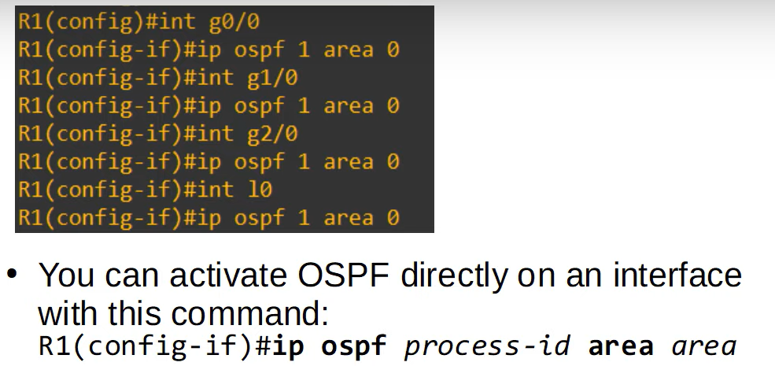

#### **Configure All Interfaces as OSPF Passive Interfaces**

You can also **remove specific interfaces** from being passive:

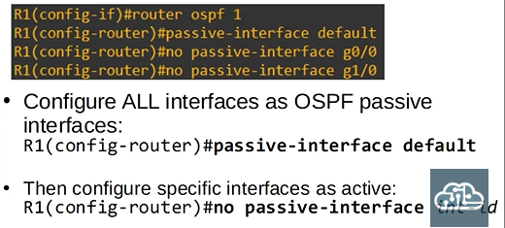

#### **Activating OSPF Directly on Interfaces**

This configuration will result in a different output when running show ip protocols. The interfaces will appear under:

**"Routing on Interfaces Configured Explicitly (Area #):"**

#### **Showing the OSPF LSDB of a Device**

